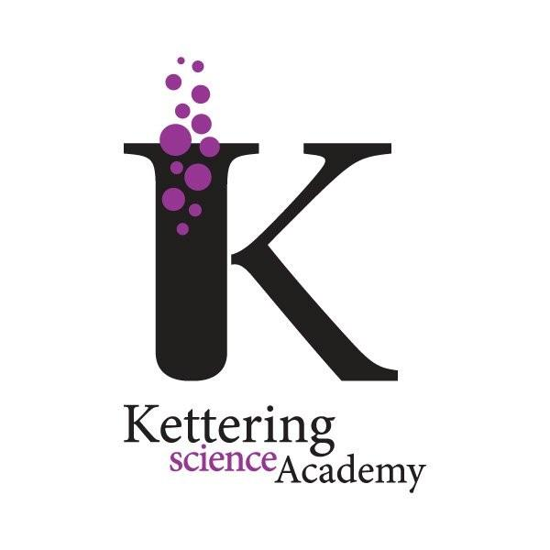
Kettering Science Academy
Deeble Road
Kettering
Northamptonshire
NN15 7AA
t: 01536 532700
w: www.ketteringscienceacademy.org
e: enquiries@ketteringscienceacademy.org
Principal: Paul Davies

Admin/Letters/LFE-WCO4515

14th November 2016

Dear Families

Austria Ski Trip 2018

We are hoping to take a group of students on a ski trip to Austria in February 2018, which will take place during the February half term. The ski trip will be fully organised by an approved company that deals with school trips. This is a lifetime opportunity for some students to gain experience on the slopes of a mountain in the Zillertal Valley, Austria and learn how to ski.

Mr Feely, one of our physical education teachers has dealt with the company before, during which time he has participated in many skiing trips. The students on these trips all enjoyed the experience and learnt some valuable skills along the way.

Students will need to have their own passport in order to travel with at least 6 months before it expires on it and any permit or visas needed if they are not a British Passport holder. They will also need a valid European Health insurance card which is available free in order to travel.

The estimated cost of the trip will be £760, which includes:

- Breakfast, lunch and dinner every day.
- Return travel to Austria by coach.
- Ski, poles, helmet and boot hire (parents are required to provide clothing).
- A ski pass for one week.
- Six days of four hour lessons with an hour’s lunch break.
- Evening activities such as bowling, swimming, ice skating etc.
- Annual ski hoody to keep.

To reserve a place please complete the attached slip and return to Student Reception with your non-refundable deposit or indicate that you have paid on Wisepay by 16th December 2016.
Please note that the deposit is strictly non-refundable unless numbers are insufficient to make the trip viable. In this case the deposit will be returned in full. Please also note that payment of the £100 deposit will indicate your commitment to the trip and obligates you to pay the trip balance in full even if you subsequently change your mind and withdraw your child from the trip.
Yours sincerely

Paul Davies
Principal

Ski Trip February Half Term 2018 (LFE)

Student’s Name: …………………………………………………………... Tutor Group: ……………………………………………..

I would like my child to participate in the ski trip to Austria during February half term 2018

I have enclosed my non-refundable deposit of £100 or I have paid on Wisepay please tick

My child will hand in a valid European Health Insurance Card prior to the trip and will have their own passport and any necessary visas or permits.

I have read the above and agree to the conditions.

Signed: ………………………………………………………………………….. Date: ………………
Parent/Guardian

Telephone No: ………………………………………… Email: ………………………………………………………………………………….

