KS3 Reading List

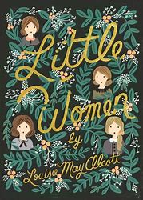
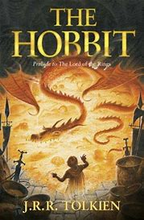
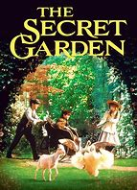
Classics
Watership Down - Richard Adams
The Secret Garden - Frances Hodgson Burnett
The Hobbit - J.R.R. Tolkien
Little Woman - Louisa May Alcott

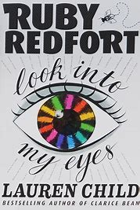
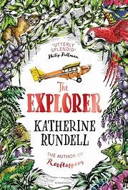
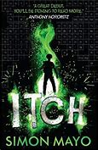
Action/Adventure
The Explorer - Katherine Rundell
Itch - Simon Mayo
Ruby Redfort: Look into My Eyes - Lauren Child
Artemis Fowl - Eoin Colfer

Sci-Fi/Fantasy
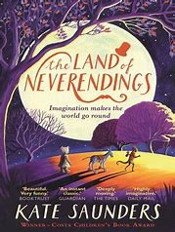
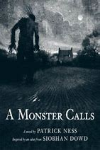
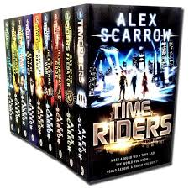
Wizards of Once - Cressida Cowell
The Lie Tree - Frances Hardinge
Northern Lights - Philip Pullman
TimeRiders - Alex Scarrow
The Land of Neverendings - Kate Saunders
The House with Chicken Legs - Sophie Anderson
A Monster Calls - Patrick Ness

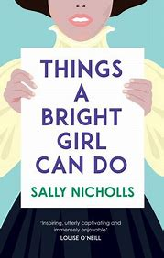
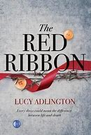
Historical
The Red Ribbon - Lucy Addlington
The Children of Willesden Lane - Mona Golabek and Lee Cohen
Things A Bright Girl Can Do - Sally Nicholls

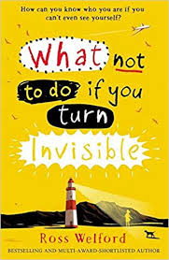
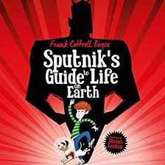
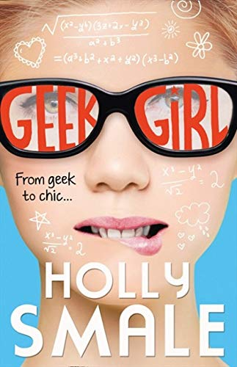
Humorous
Sputnik’s Guide to Life on Earth - Frank Cottrell Boyce
What Not to Do if you Turn Invisi0ble - Ross Welford
Geek Girl - Holly Smale

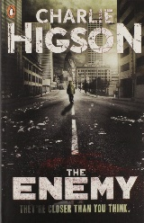
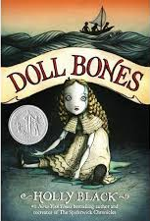
Horror
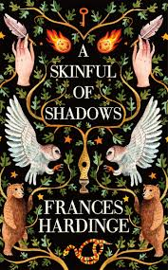
The Graveyard Book - Neil Gaiman
Skulduggery Pleasant - Derek Landy
The Enemy - Charlie Higson
Doll Bones - Holly Black
A Skinful of Shadows - Frances Hardinge

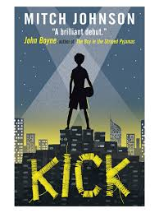
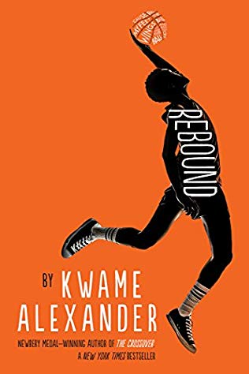
Sport
The Crossover - Kwame Alexander
Kick - Mitch Johnson
The Weight of Water - Sarah Crossan
Armistice Runner - Tom Palmer
Rebound - Kwame Alexander

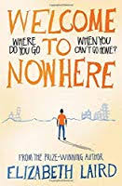
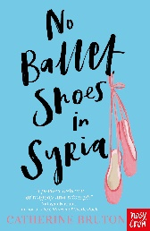
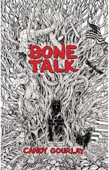
Around the World
Welcome to Nowhere - Elizabeth Laird
Running on the Roof of the World - Jess Butterworth
Jasmine Skies - Sita Brahmachari
No Ballet Shoes in Syria - Catherine Bruton
Bone Talk - Candy Gourlay

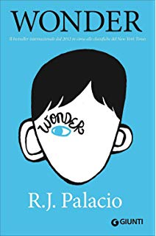
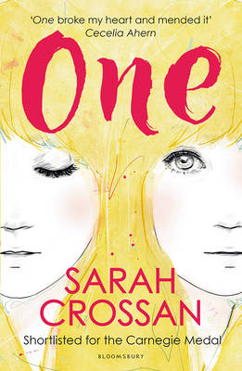
Real Life
One - Sarah Crossman
Wonder - R.J. Palacio

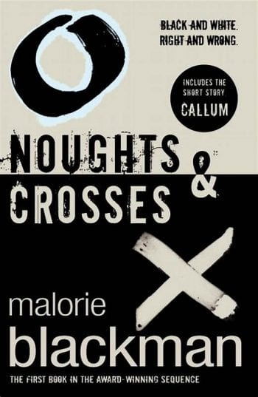
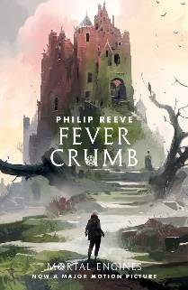
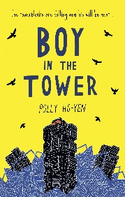
Dystopian
After Tomorrow - Gillian Cross
Boy in the Tower - Polly Yo-Hen
Noughts and Crosses - Malorie Blackman
Fever Crumb - Philip Reeve

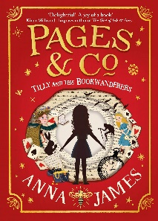
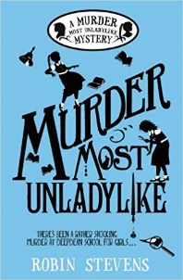
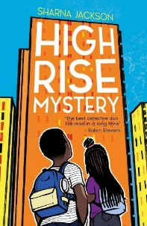
Crime/Mystery
High Rise Mystery - Sharna Jackson
The London Eye Mystery - Siobhan Dowd
Murder Most Unladylike - Robin Stevens
Pages & Co: Tilly and the Book Wanderers - Anna James

