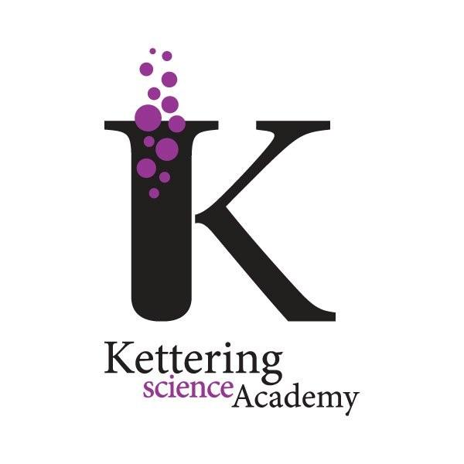
Kettering Science Academy
Deeble Road
Kettering
Northants
NN15 7AA
t: 01536 532700
w: www.ketteringscienceacademy.org
e: enquiries@ketteringscienceacademy.org
Principal: Tony Segalini

Weekly Update 23/09/2023
I hope this letter finds you well and you have had a good week. Another video version accompanies this letter if you prefer listening rather than reading as I appreciate there is a lot of information this week! The link to this is https://youtu.be/09aCTD0lIxg.

Feedback
My continued thanks for all of you who have been getting in touch with us – both about the things we are doing well, and the things we can do better. As I mentioned in my previous communication, Mr Taylor is going to be sending out something next week to capture your views on our uniform and we will also be asking students. Please do keep an eye out for this and take a few minutes to complete the form – I would like to hear as many voices as possible.

Meet the Tutor Evening
A huge thank you to all the Year 7 parents who attended our Meet the Tutor Evening last night. We had a brilliant turnout of about 80% of our parents and it was great to see all the happy faces and hear the animated chats within the hall.

I would like to extend this event in the future to include other year groups as I think it’s important at the start of each year for you to have the opportunity to connect with your child’s tutor. If you are the parent of a child in a year group other than Year 7, and would like to speak to your child’s tutor, please do get in touch and we will be happy to arrange a chat.

Getting In Touch With Us
I wanted to take the opportunity this week to let you know about some of the ways you can get in touch with the school.

Absences / Medical Appointments
The best way to do this is via Edulink as this goes directly to our Attendance Officer.

Issues / Concerns
If these are of a general nature, please contact your child’s tutor or Head of Year. If it is related to a specific subject, please contact the subject teacher or Head of Department. Key email addresses are on our website and can be found in the About Us drop down menu under Who’s Who.

We are currently working on a graphic which will give more information about which senior member of staff is linked to each area within the school, so you also know who to escalate your concerns to if you feel they have not been resolved.

General Enquiries
When you call the school number, if the line is busy then you can stay on the line where you will be updated periodically with your place in the virtual queue or you have the option to leave a voicemail. These are monitored and actioned throughout the day. You are also able to email us on reception@ketteringscienceacademy.org.

We are going to look at setting up a telephone ‘bounce’ which will mean if the line is busy, it will put you through to another member of our administrative team. We hope this will provide some further capacity.

School Entry / Exit
We have had some feedback about the way in which our students enter and exit the school site, especially in relation to the absence of a bike lane on the hill towards the Ise Lodge. In response to this, we are going to increase our staff presence at the school gates and along this road.

We are also going to be outlining our expectations of bike / scooter etiquette with our students and making clear that a condition of bringing a bike or scooter onto the school site is dependent upon them following these expectations. Specific details will be shared with students and you next week so that everyone is clear on the expectations before we start insisting on these.

We have also asked for the overgrown shrubs and nettles to be cut back which are impacting on the path space.

Standards
As part of our reiteration of our expectations in relation to the entry and exit to the school, we will also be taking the opportunity to remind students of our expectations in terms of their conduct in and around the Academy, particularly at social time.

Overall, our students embrace our core values and conduct themselves in an exemplary fashion. Students know that where this might not be the case, we will make certain there is follow up and any necessary action is taken.

We have a zero-tolerance approach to child-on-child abuse, and I have asked Mrs Merry, Assistant Head, who oversees safeguarding to share with you the assembly she delivered to all students this week. I think it’s important you see and hear the support we have in place and what we do to ensure the safety of our children is our number 1 priority. Mrs Merry and her team are always more than happy to help support in any way they can, so please do feel free to get in touch following the video she is going to send if you have any further questions.

And finally…
I am now 3 weeks in, and I have loved every moment. It’s clear to me that there is so much unlocked potential at the school on top of all the other good stuff which goes on. As you will hear me say many times, that doesn’t mean we always get everything right and we know we have lots more to do. But I have huge confidence that the entire KSA community can achieve anything we set our minds to.

Wishing you a lovely weekend.

Mrs Giovanelli

