KS4 Reading List

Horror
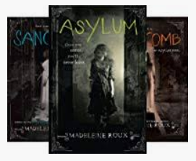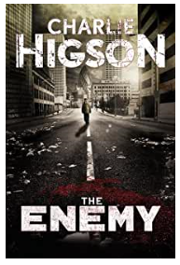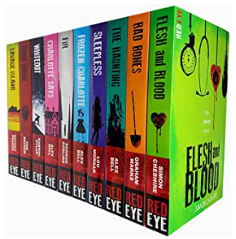

The Wasp Factory – Ian Banks
World War Z – Max Brooks
The Enemy Series – Charlie Higson
Red Eye Series – Alex Bell
Asylum Series – Madeleine Roux

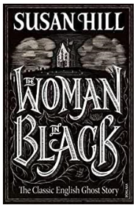
Classics
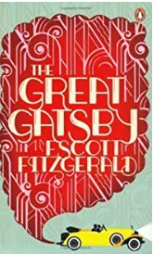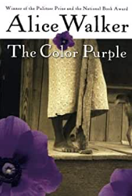
Frankenstein – Mary Shelley
To Kill a Mocking Bird – Harper Lee
The Woman in Black – Susan Hill
The Great Gatsby – F. Scott Fitzgerald
The Colour Purple – Alice Walker

Historical
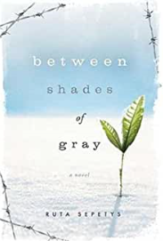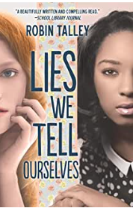
Between Shades of Grey – Ruta Sepetys
Wolf Hall – Hilary Mantel
Code Name Verity - Elizabeth Wein
Lies We Tell Ourselves – Robin Talley
The Gentleman’s Guide to Vice and Virtue – Mackenzie Lee

Around The World
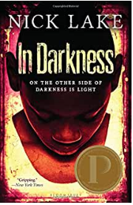
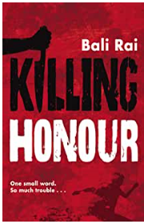
The Kite Runner – Khalid Hosseini
Wild Swans – Jung Chang
In Darkness – Nick Lake
Killing Honour – Bali Rai
The Glass Collector – Anna Perera

War
The Book Thief – Marcus Zusak
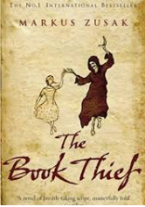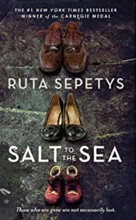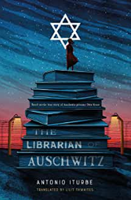
Birdsong – Sebastian Faulkes
All Quiet on the Western Front – Erich Maria
The Librarian of Auschwitz – Antonio Iturbe
Salt to the Sea – Ruta Sepetys

Dystopian
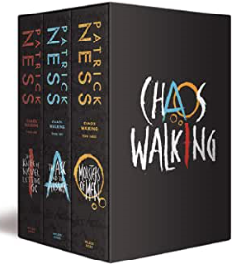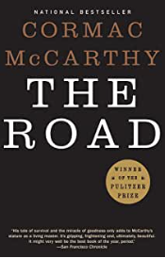
The Road – Cormac McCarthy
Uglies – Scott Westerfield
1984 – George Orwell
The Fifth Wave – Rick Yancy
Chaos Walking Trilogy – Patrick Ness

Crime/Mystery
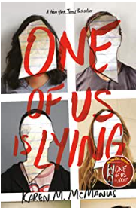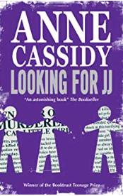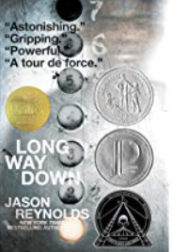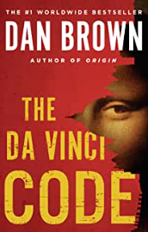
Looking For JJ – Anne Cassidy
A study in Scarlett – Arthur Conan Doyle
The Da Vinci Code – Dan Brown
Long Way Down – Jason Reynolds
One of Us Is Lying – Karen M McManus

Humour
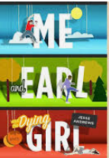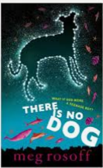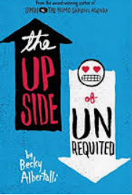
Bridget Jones Diary – Helen Fielding
The Is No Dog – Meg Rossoff
The Upside of Unrequited – Becky Albertelli
Me Earl and the Dying Girl – Jessie Andrews
The Absolutely True Diary of a Part-Time Indian – Sherman Alexie

Fantasy
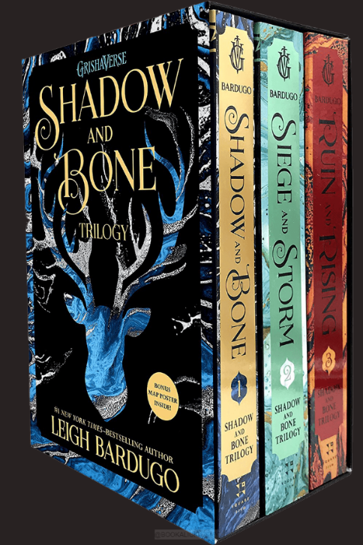
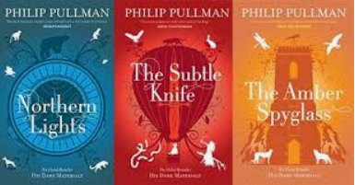
His Dark Materials – Phillip Pullman
Wolf of Mercy Falls Trilogy – Maggie Stiefvater
Grisha Novels – Leigh Bardargo
A Court of Thorns and Roses – Sarah J Maas
Shatter Me – Tahereh Mafi

Science Fiction
The Hitchhikers Guide to the Galaxy – Douglas Adams
Warcross – Marie Lu
Scythe – Neil Shusterman
The Lorian Legacies – Pitticus Lore
Noughts and Crosses – Malorie Blackman

Action Adventure
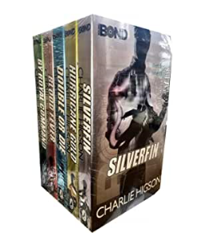
Alex Rider Series – Anthony Horowitz
Young Bond Series – Charlie Higson
Cherub Series – Robert Muchamore
The Dogs of Winter – Bobbie Pyron
The Wolf Wilder – Katherine Rundell

Thriller
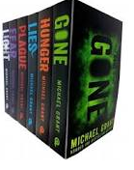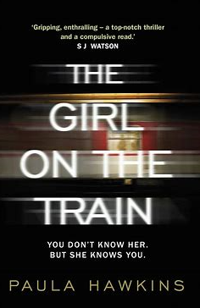
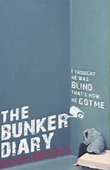
Silence of the Lambs – Robert Harris
Gone Series – Michael Grant
The Girl on the Train – Paula Hawkins
The Bunker Diary – Kevin Brooks
13 Minutes – Sarah Pinborough

Growing Up Is Hard To Do
The Art of Being Normal – Lisa Williamson
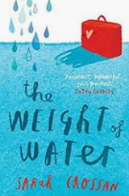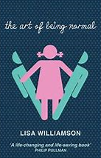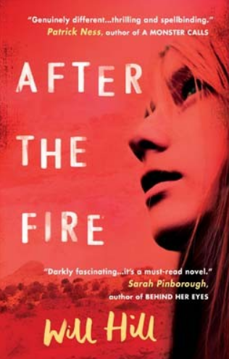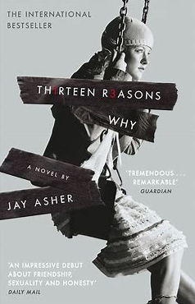
Thirteen Reasons Why – Jay Asher
More Happy Than Not – Adam Silvera
The Weight of Water – Sarah Crossan
After the Fire – Will Hill

Romance
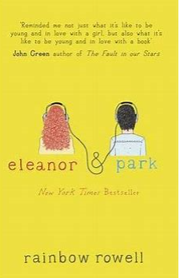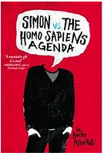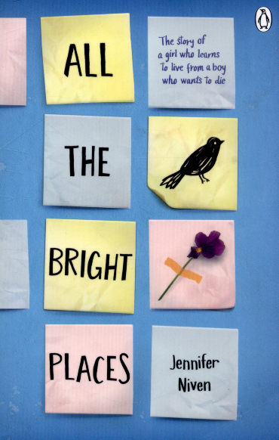
Eleanor and Park – Rainbow Rowell
The Fault in our Stars – James Green
Simon vs The Homosapiens Agenda – Becky Albertelli
Our Chemical Hearts – Krystal Sutherland
All The Bright Places – Jennifer Niven
